Percent RPM Gauge.xml

For convert the default FS9 P&W-PT-6 turboprop engine in a Garrett TPE331.

It is a very unrealistic fly experience, i.e.: fly a Short’s Skyvan or a Turbocommander (Garrett engines equipped aircrafts) and has not the matching visuals (gauges) and audible pilot sensitive stimulus.

As many FS simmers knows, FS9 has modeled only one turboprop type: the Pratt & Whitney PT-6 engines but there are others aircrafts that uses the Garrett one, which differ mainly in the way they works.

The first uses two independent shafts, N1 and N2, one for the gas producer and the other for the power section.

The Garrett is a single shaft engine; the gas producer is in the same axis than the power section.

Technically the differences are: the P&W-PT-6 has an easier and fast start process and in counterpart the Garrett has a more proficient fuel consumption ratio.

But in the cockpit side are differences to. The main are: N2 becomes unnecessary. The P&W-PT-6 RPM gauges (Prop. and N2) becomes in a single ‘Percent RPM’ gauge in the Garrett.

In the power pedestal there are just Power Levers and Condition Levers (no fuel handling levers).

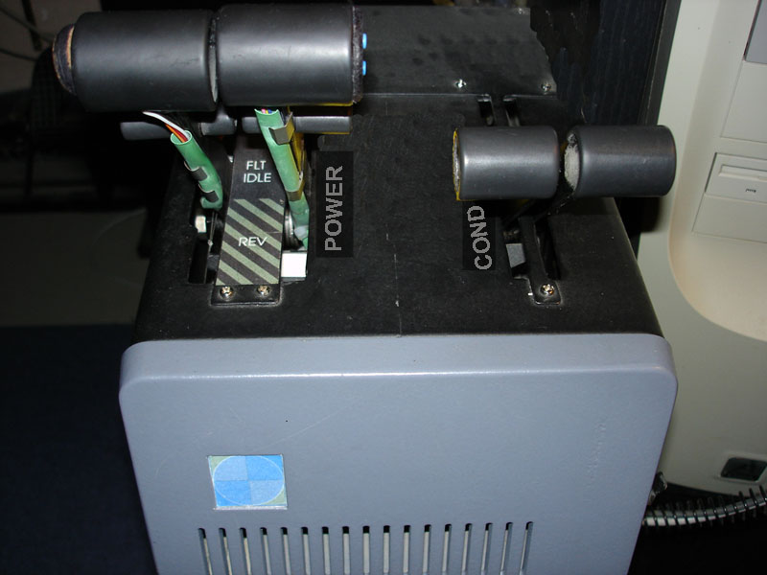

This is my home-build throttle quadrant. Two Power Levers and two Condition Levers (note the reverse locks) Has an Elevator Trim switch in Power Lever #1 and Autopilot & Autotrhottle Disengage buttons in Power Lever #2.

One of the most audible difference is when engines idles (Garrett idle speed is at 70% RMP) is a very noisy engine in ground operation.

The challenge was hard because I must deal with the non open part of FS9 architecture, the non conventional area for tweak.

I did a great search for see if there was a way to interact with the internal FS9 sound engine with no success. This was my first strategy approach; intercept the main FS sound system and try making it operate in a Garrett way. This was not possible.

The final approach was done by working over what the pilot sees and hears; in other words, let the pilot see the gauges with the Garrett engine behavior and accompany this with a believable and accordingly engine sound.

The first thing I must get, was make the ‘Percent RPM’ gauge do no fall bellow 70% when engine is idling or when power is reduced (normal in P&W PT-6).

In conclusion I decided to link the Condition Lever (A:general Eng1 propeller lever position, part) to drive the RPM gauge, instead of reading N1 or N2. And here becomes a stream of new challenges:

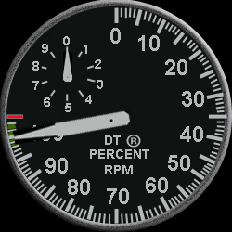

In this gauge resides the main work load.

- The gauge has two needles, the small one for 10th RPM% each turn and the great one which indicates RPM over a normal 270º scale. How to synchronize the two needles and how to synchronize the levers travel in conjunction with the gauges indications? Consider: full forward is 100% RPM and full back lever position is 70% RPM.
- What when engines stops? Keep in mind, RPM gauge has not N1 or N2 info.
- How synchronize the two needles? (small must be North each time great is in a 10th of scale).
- And what about the speed which I move the Condition Levers? What if I forward the levers in a fast push? How to avoid the small needle ‘jump’?
- Other chapter is the sounds. Normally when apply full RPM in a P&W-PT-6 engine, torque gauge go to zero and the sound pitch and volume level decreases accordingly. This is just the inverse must happen with Garrett. It is supposed when you apply full RPM the engines becomes more loudly (in pitch and volume).
- Fortunately I found the great magician: Doug Dawson and his Sound Gauge to solve this. I build three different sounds for play; one for the acceleration phase, other for play when the engine is stabilized at 100% RPM and the last which plays during decrease RPM phase, sounds that must play in combination with the main FS sound system.
- And again, what with the sounds when engines stops?
- Synchronizing the sounds. What if apply full RPM and the acceleration face sound didn’t finish? I must implement a timer in the code for insert a delay who makes wait the sustained sound to play until the acceleration sound ends (here I had good help from AVSIM Forum people, thanks).
- Adjust the sound level of the simm sound engine in juxtaposition by the superimposed sounds with the Doug’s Gauge, for get a believable final sound.

For finish: There are yet some bugs in the ‘Percent RPM’ gauge. But at the present time the gauge is doing exactly what I expected.

The next code fragment rotates the small needle and has a bug in it.
It is expected this needle must rotate 10 times as maximum.
Note I need put <Value Maximum=”19”> for get the needle turns 10 times (from a stopped engine and to the 100% RPM range)
Also had to multiply by 20 (A:general eng2 propeller lever position,part).
The addition of 13.2 is for synchronize the needles positions.

I think the bug is in the <Item Values…/> coordinates. In someplace of the Item Value interpolation the needle needs two times the food for do a single turn!

The code fragment:
<Value Maximum="19">(A:general eng2 combustion, bool) if{ (A:general eng2 propeller lever position,part) 20 * 13.2 + } els{ 0 (&gt;A:general eng2 propeller lever position,part) }</Value>
<Nonlinearity>
<Item Value="0" X="0" Y="173"/>
<Item Value="0.25" X="80" Y="0"/>
<Item Value="0.5" X="250" Y="173"/>
<Item Value="0.75" X="80" Y="250"/>
<Item Value="0.9" X="0" Y="236"/>
</Nonlinearity>

I tried turning the small needle using the radians way, but I found this method so fast to execute the turns that when I moves the Condition Lever with ‘heavy hands’ the needle jumps in half circles. Needs move the lever carefully slow for have smooth needle turns.

But so, as the code is, the gauge does exactly what must to do!

This ‘RPM Gauge’ can be installed in any aircraft equipped with a turboprop engine and needs emulate the Garrett one. Also you will need an accordingly Garrett main sound package, and build with your sound editor a set of three sounds for the acceleration phase , sustain at 100% RPM phase sound and the decrease RPM phase sounds.
Dismount from the panel the N2 gauge –gas producer- (if installed).

ADVICE:
The gauge code includes call’s to Doug Dawson Sound Gauge which has is own copyright.
Doug Dawson ‘XML Sound Gauge’ is a ‘Must-Have’ freeware tool for play extra sounds simultaneously with the main FS sounds.
The file name: anddsd_xml_sound2.zip for download from the AVSIM library.
The pack contains good instructions with a tutorial for implement the ‘XML Sound Gauge’
Thanks Doug for your dedication!

Dirk Trotteyn (SANT)

Comments and questions are welcome:
dirkt@arnet.com.ar
For spam avoidance please write XML in the mail subject.

Files Included:

DT_RPM_Left.xml
DT_RPM.bmp
DT_NEEDLE_LG.bmp
DT_NEEDLE_SM.bmp
This file.

Note 1: not included the three sound files (weight 3 MB!).
Note 2: I’m learning XML and writing English!

Tucumán, 12 JUN 2005.-

